### Starting point

Having a headless eclipse plug-in project. It can be executed like this: “eclipse.exe -application plugInProjectName.id -parameters”.

As a specific example, here is a command:

C:\Users\Billy\GitHub\eclipse\eclipse-java-luna-SR2-win32-x86_64\eclipse\eclipse -application testMonitor3.id5 -consoleLog -noExit inputDir/ outputDir/output.xml -vmargs -Xmx10240M

### Steps for exporting eclipse product

Create a product configuration file

1. Right click on the plug-in project -> new -> product configuration
2. In the configuration window, enter a file name for this configuration file. Click finish.
3. The new file should show up under the project.

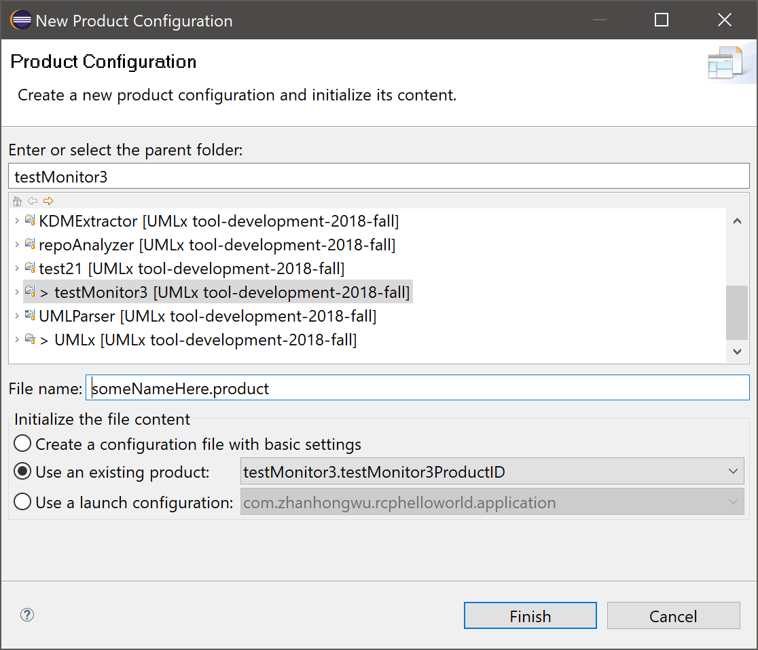

Create a new product definition

1. Open the configuration file of last step.
2. In the “Product Definition” section, click on “New...".
3. Enter some details. Note the “Application” must be the plug-in you want to export.
4. Click finish. The product definition should show in “Product Definition” section.

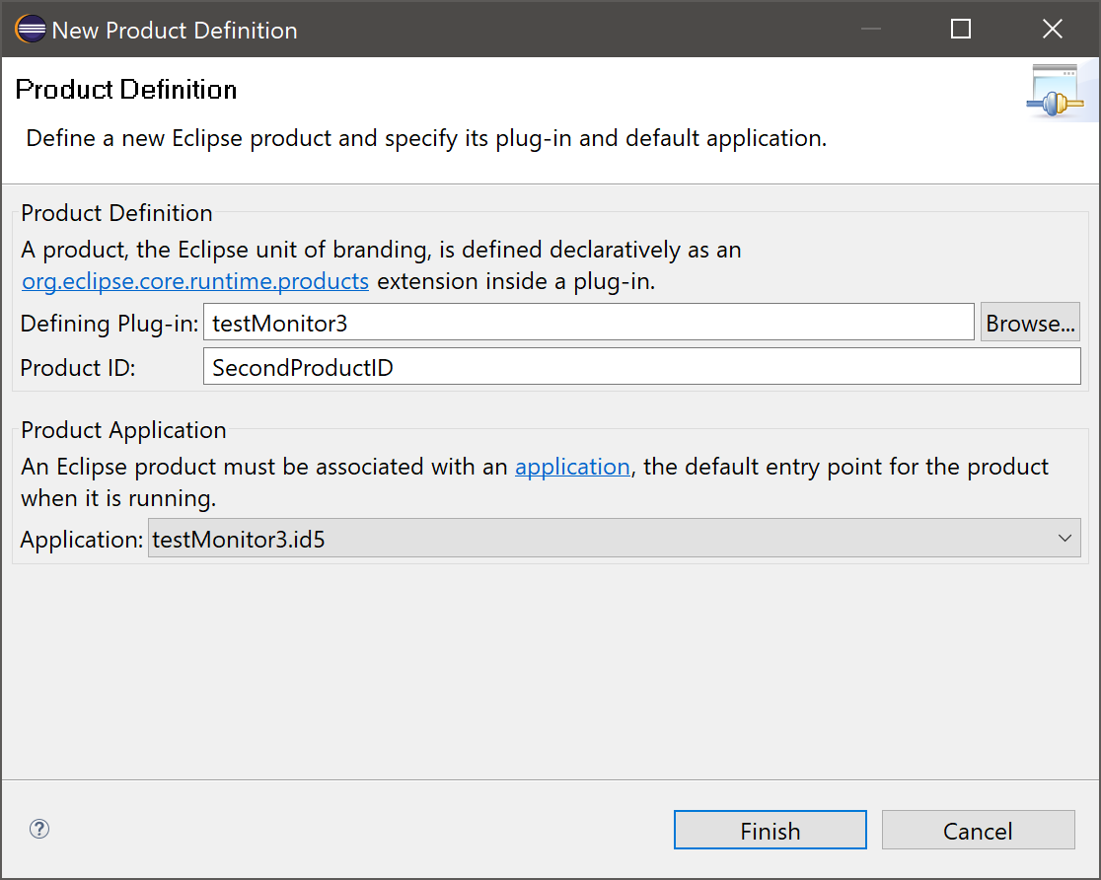

Add dependencies

1. Click on the “Dependencies” tab. See the next screenshot if you can’t find it.
2. Click “Add Required Plug-ins”.

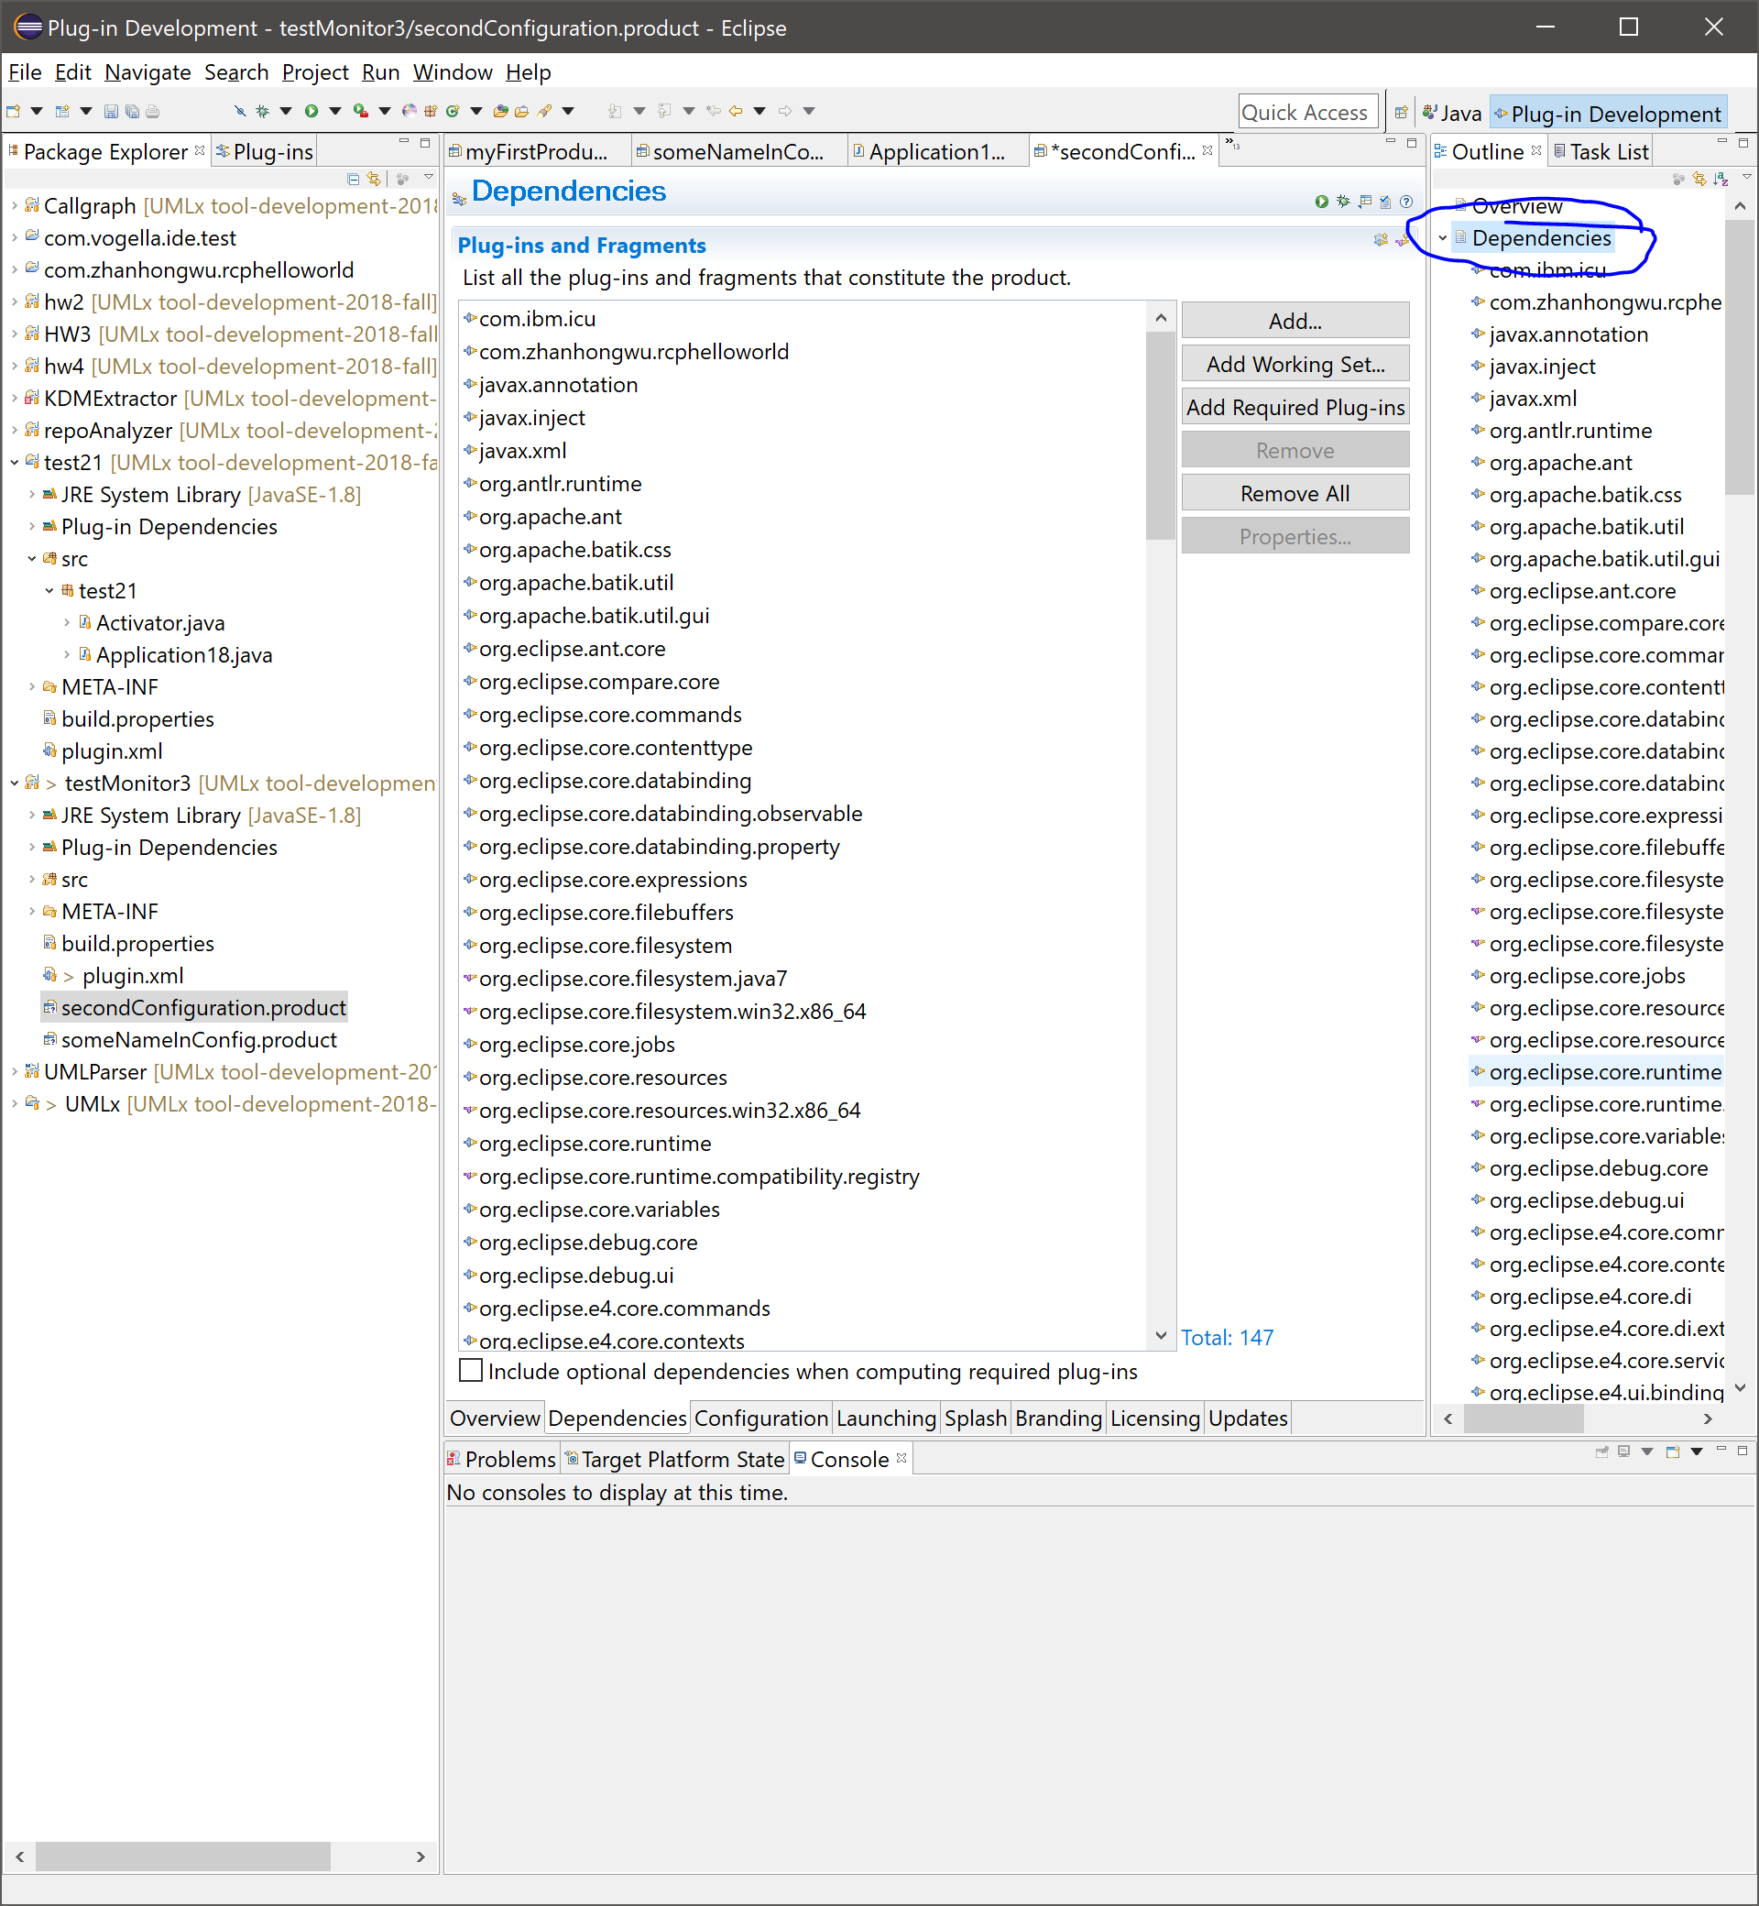

Export

1. Go back to the “overview” tab.
2. In the “Exporting” section, click “Eclipse Product export wizard”. A window should open.
3. Select a output directory in the “Destination” section.
4. Check the “Export for multiple platforms” checkbox.
5. Click next.
6. Select the platform(s) you want to run the product on. Click finish.

Note:

1. If exporting to linux fails, try this guide to install additional packages to eclipse <https://stackoverflow.com/a/12737382>. Also repeat the adding dependencies step.

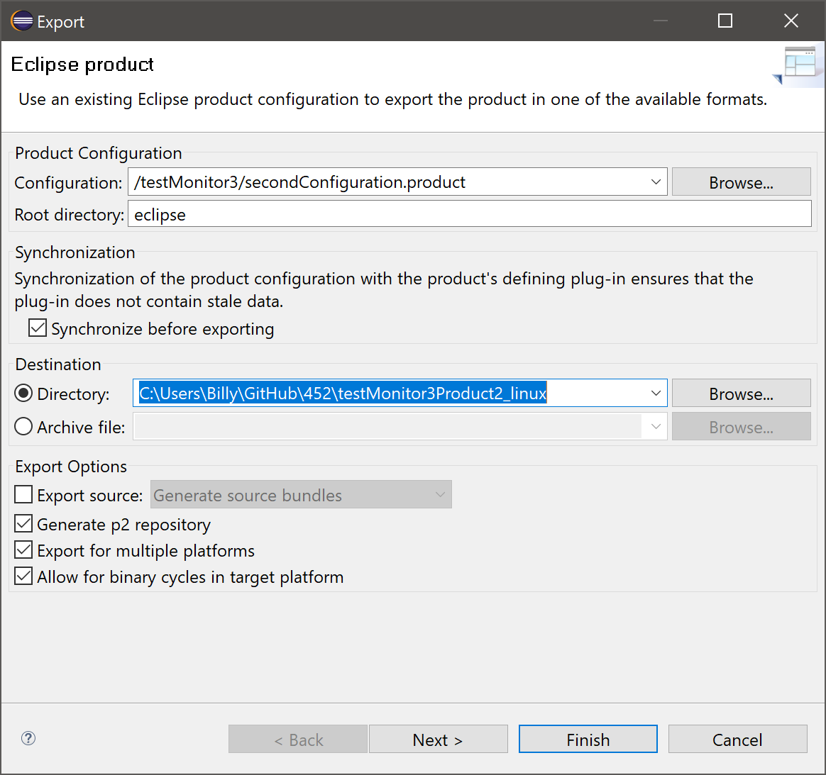

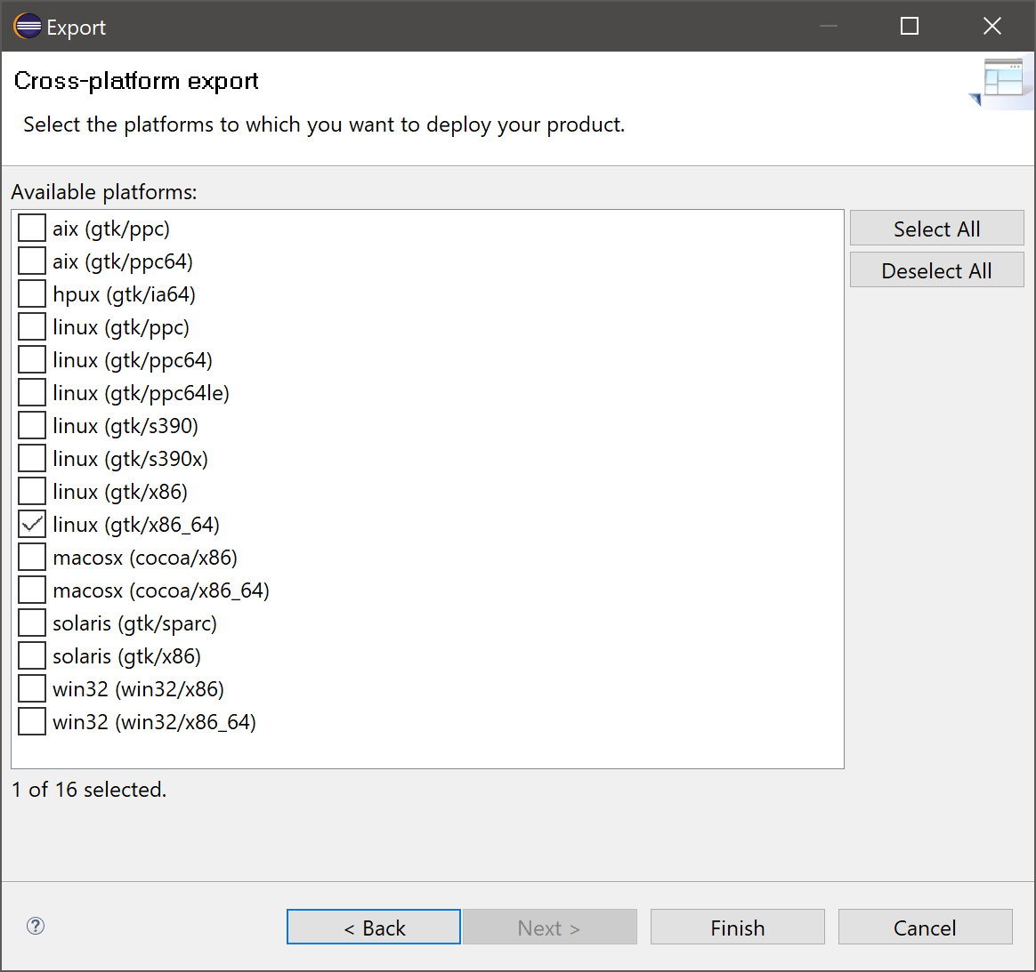

Test if it works

1. Go to the output directory. Find the eclipse executable file. It will be a file called “eclipse.exe” if exported for windows, or “eclipse” if exported for linux.
2. Run the executable on command line. Replace “eclipse.exe -application PlugInName.id” with the exported “eclipse.exe”. It should work the same way.

Note

1. For linux export, the same version of JDK is required. E.g. if the plugin works on Windows with Oracle JDK 1.8, Oracle JDK 1.8 should also be installed on linux.

Reference

<http://obscuredclarity.blogspot.com/2008/11/hello-world-with-eclipse-rcp-your-first.html>

<https://www.programcreek.com/2012/01/export-eclipse-rcp-to-product/>